MTH 200 | Fermat’s Theorem, Rolle’s Theorem, & MVT

Directions: Solve all problems on a separate sheet(s) of paper. Place your name on the pages you submit. You must show all of your work to receive full credit on problems. You must write complete sentences when asked to show/prove something or provide an explanation/justification. You are encouraged to work with others, consult sources, use calculators, etc. However, only submit solutions that you fully understand. Do not submit solutions which are copied from a friend or another source.

Challenge Questions

MVT, ROLLES, FERMATS

- A person begins cycling from home at noon. She begins cycling quickly and travels 3 miles norther. Then she makes a U-turn without stopping, and then cycles home slowly. She finishes cycling after 30 minutes. Let be a function that represents the total distance traveled versus time.
- Construct and label a possible graph of .
- Construct a line segment on the graph from part (a) from the starting point to the ending point. On the graph, label the point c guaranteed by the appropriate theorem.
- Refer to the cycling context of the problem to describe what the point c means in the problem.

- Let .
- If and , what value c satisfies the conclusion of the MVT?
- If and , what value c satisfies the conclusion of the MVT?
- If and , what value c satisfies the conclusion of the MVT?
- In general, what value c do you anticipate satisfies the conclusion of the MVT for any a and b with this polynomial?
- Suppose that . Show that the number c that satisfies the conclusion of the MVT for any polynomial is given by

- Show that the equation has exactly one real root.
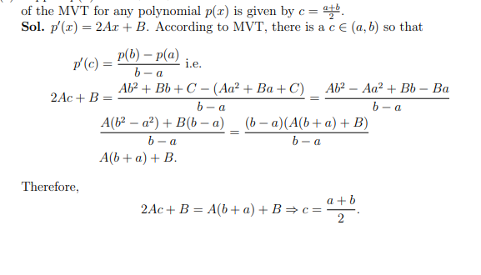

- Indicate which Mathematical Theorem best fits the statement.

Fermat’s Theorem
Intermediate Value Theorem.
Extreme Value Theorem
Mean Value Theorem
Fundamental Theorem of Calculus

- There was a maximum temperature in the last 24 hours.
- A ball tossed in the air will be at its highest point when it stops moving for an instant.
- On a trip, the distance form the end compared to the beginning is measured by the area under the graph of the velocity.
- A fish that jumped above the surface of the water will make a splash before it is again underwater.
- If you travel 90 miles in 2 hours, at some time you were traveling 45 miles per hour.

